**PROGRAM1**

f1=open("firstfile.txt","w")

f1.write("This is my first file in python.\nWant to work with files.\n This is my third")

f1.close()

f1=open("firstfile.txt","r")

f1.seek(0,0)

ff=f1.readlines()

for x in range(0,len(ff)):

print(ff[x])

print()

#f1.seek(0,0)

#ff=f1.readlines() #return list of all lines

print(ff)

f1.close()

Output:

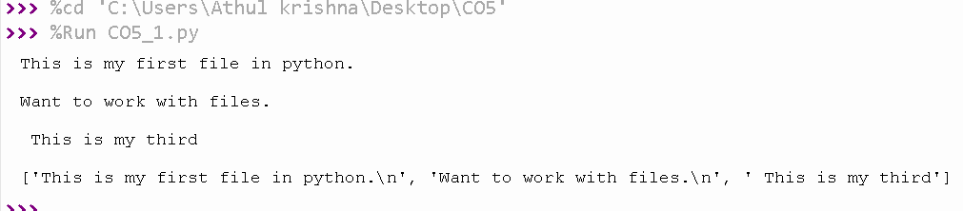

**PROGRAM2**

f1=open("firstfile.txt","r")

for x in f1:

print(x)

f1.seek(0,0)

print()

f2=open("odd.txt","w")

ff=f1.readlines()

with open('odd.txt','w') as f2:

for x in range(0,len(ff)):

if(x%2!=0):

print(ff[x])

f2.write(ff[x])

Output:

